1. DATA FLOW DIAGRAM

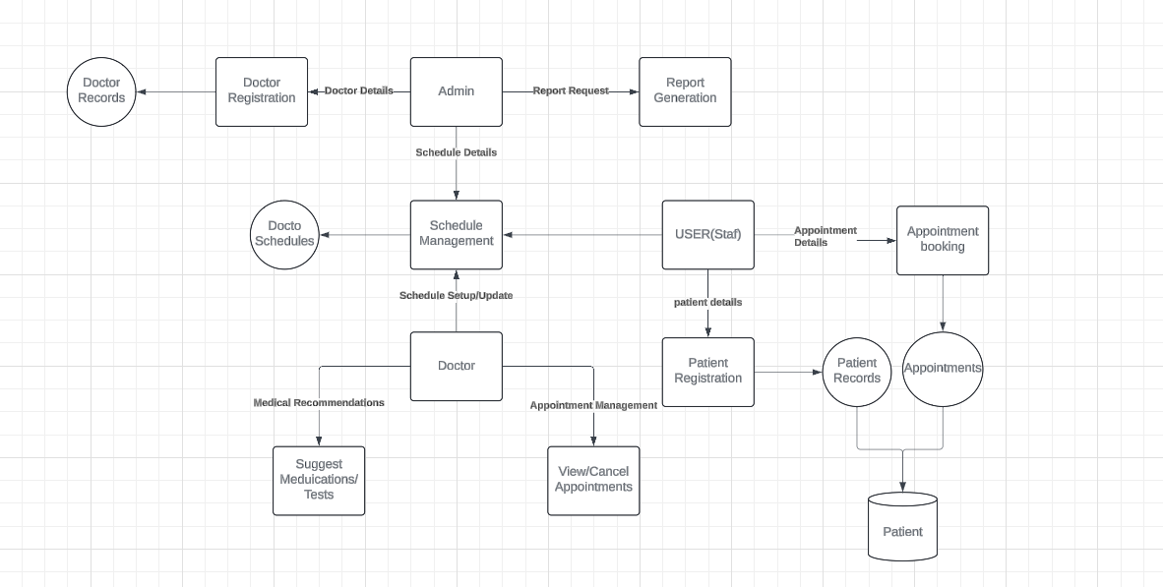

1. ER DIAGRAM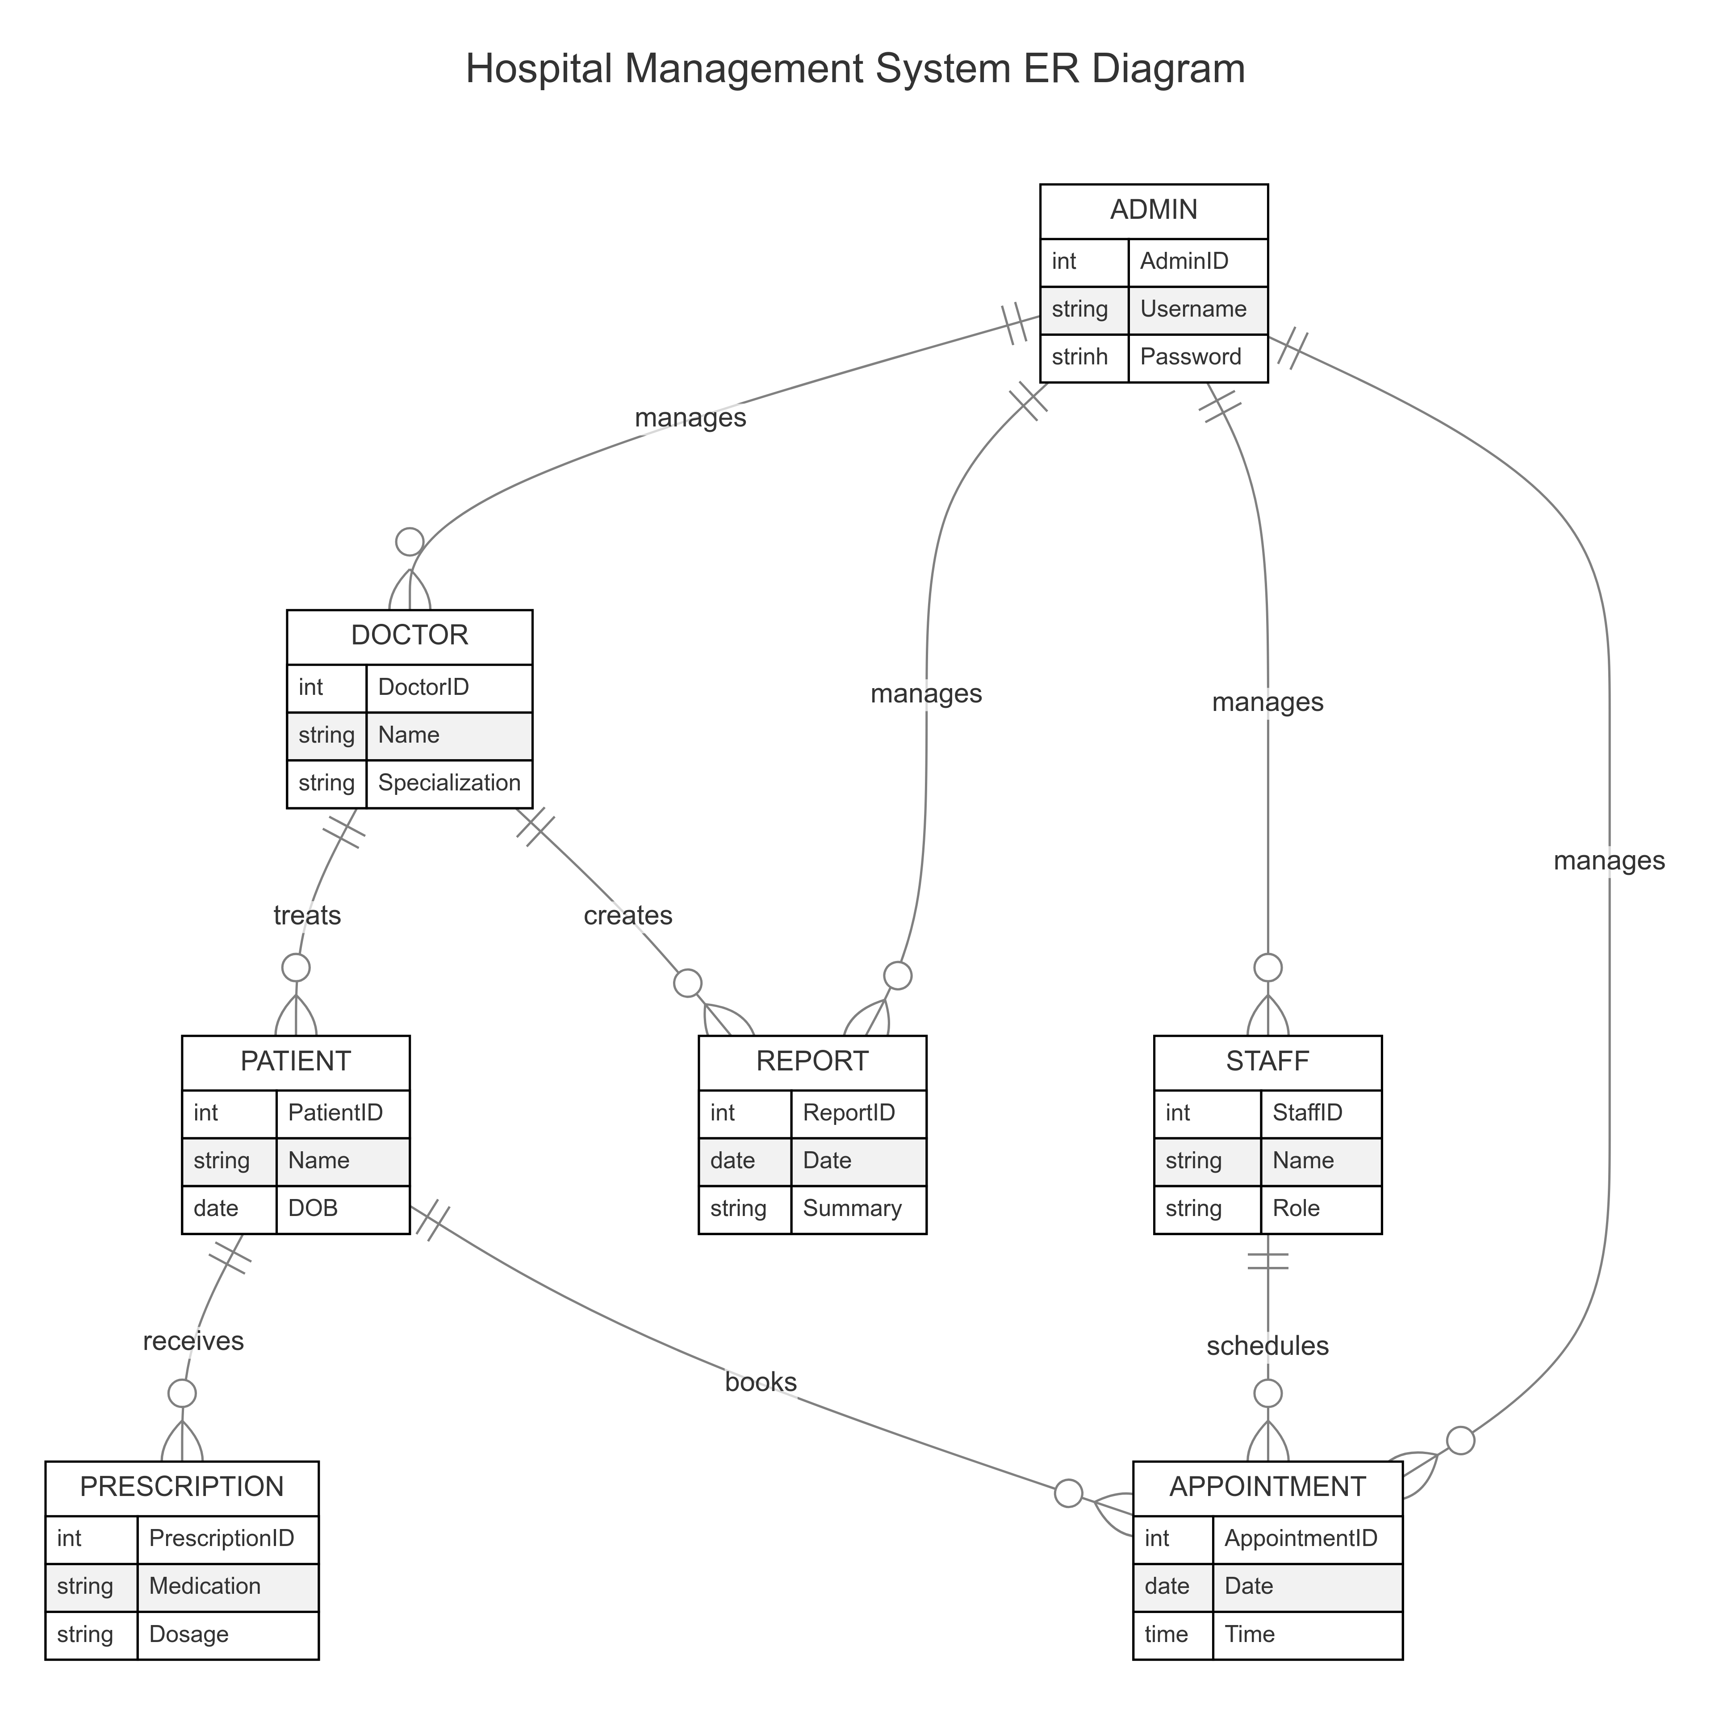
2. CLASS DIAGRAM  
   